## 3AB CHEMISTRY SEMESTER TWO, 2015

# 3AB CHEMISTRY EXAMINATION

**READING TIME: 10 Minutes**

**WORKING TIME: 3 Hours**

**This examination is in three parts:**

**SECTION ONE:**  25 Multiple Choice - 25 Marks

**SECTION TWO:**  11 Short Answer - 35 Marks

**SECTION THREE:**  4 Extended Answer - 40 Marks

100 Marks

**INSTRUCTIONS:**

1. Attempt ALL questions. Put your **NAME on the first page of each new answer booklet for the short answer and extended answer sections as well as on the multiple choice answer sheet.**

2. Marks will be awarded for method despite an incorrect final result provided working is WELL SET OUT, NEAT and LEGIBLE. You will lose marks even if the answer is correct if you have shown insufficient working.

3. A **scientific calculator** is allowed and a periodic table and data chart is supplied.

**STRUCTURE OF THE PAPER**

|  |  |  |  |  |
| --- | --- | --- | --- | --- |
| **Section** | **No. of Questions Set** | **No. of Questions to be Attempted** | **Marks Allocated** | **Recommended Time (approx) in Minutes** |
| Section1:  Multiple-choice | 25 | 25 | 25 (25%) | 50 |
| Section 2:  Short answers | 11 | 9 | 35 (35%) | 60 |
| Section 3:  Extended answer | 4 | 4 | 40 (40%) | 70 |

**Total Marks for Paper = 100 (100%)**

**INSTRUCTIONS TO CANDIDATES**

**Reading Time**: The examiners recommend that candidates spend the reading time mainly reading the Instructions to Candidates and Sections One, Two and Three.

***Section One - Multiple Choice***

Answer on the separate Multiple Choice Answer Sheet.

If you consider that two or more of the alternative responses are correct, choose the one that you think is best. If you think you know an answer, mark it even if you are not certain you are correct. Marks will not be deducted for incorrect answers. No marks will be given if more than one answer is completed for any question.

FEEL FREE TO WRITE OR DO WORKING OUT ON THE QUESTION PAPER. Many students who score high marks in the Multiple Choice Section do this.

***Sections Two and Three***

Use a ballpoint or ink pen. You may not answer in pencil. Write your answers in the answer books provided. You may use the ***back and front*** of the paper but make sure that **EACH NEW ANSWER BOOKLET** has your name on it.

**CHEMICAL EQUATIONS**

For full marks, chemical equations should refer only to those species consumed in the reaction and the new species produced. These species may be **ions** [for example Ag+(aq)], **molecules** [for example NH3(g), NH3(aq), CH3COOH(aq)] or **solids** [for example BaSO4(s), Cu(s), Na2CO3(s)]. Phases MUST be shown in the equations for the first question of the short answer section.

**Section One: Multiple-choice 25% (25 Marks)**

This section has **25** questions. Answer **all** questions on the separate Multiple-choice Answer Sheet provided. For each question place a cross in the box to indicate your answer. Use only a **blue or black pen** to cross the boxes. If you make a mistake, circle the incorrect answer and place a cross in a new box.

**Suggested working time: 50 minutes.**

1. A student was performing a titration to determine the concentration of ammonia in a household floor cleaner. They pipetted 20 mL aliquots of floor cleaner into a conical flask and poured standardised hydrochloric acid solution into the burette. Which of the following would have caused the student’s calculated ammonia concentration to be lower than it actually is?

1. Rinsing the pipette with water before use
2. Using methyl orange indicator
3. Rinsing the burette with water before use
4. Rinsing the conical flask with the floor cleaner before use

2. Which two of the following compounds may be used as primary standards in quantitative analysis?

1. Na2CO3 (s)
2. NaOH (s)
3. H2O2 (1)
4. HCl (aq)
5. H2C2O4 (s)

(a) i) and ii)

(b) i) and v)

(c) ii) and v)

(d) i) and iv)

3. A student designs an electrochemical cell. One half cell consists of a nickel rod in a 1 mol L−1 nickel (II) sulfate solution. As the cell operates he notices that the green colour of this half cell becomes darker green. Which of the following could correctly describe the other half cell?

1. Chromium rod in a chromium (III) chloride solution
2. Copper rod in a copper (II) sulfate solution
3. Lead rod in a lead nitrate solution
4. Zinc rod in a zinc chloride solution

(a) I and II

(b) II and III

(c) III and IV

(d) I and IV

4. In which of the following species does platinum have the lowest oxidation number?

(a) H2PtCl6

(b) NaPtCl4

(c) Pt2O3

(d) PtCr2O7

5. In which of the following reactions is hydrogen peroxide the oxidant (oxidising agent)?

1. 3 H2O2(aq) + Cr2O72-(aq) + 8 H+(aq) → 3 O2(g) + 2 Cr3+(aq) + 7H2O(l)
2. H2O2(aq) + Cl2(g) → O2(g) + 2 H+(aq) + 2 Cl-(aq)
3. 3 H2O2(aq) + 6 H+(aq) + 2 Au(s) → 6 H2O(l) + 2 Au3+(aq)
4. H2O2(aq) + 2 Fe3+(aq) → O2(g) + 2 H+(aq) + 2 Fe2+(aq)

6. An electrochemical cell was set up as shown in the diagram below using two metals, X and Y, and their corresponding aqueous salts, X2+ and Y2+.

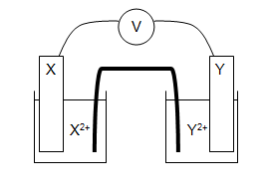

The emf was recorded to be 0.58 V. Assuming standard conditions, which pair of half-cells is most likely to have been used in the construction of this cell?

1. Zn / Zn2+ and Cu2+ / Cu
2. Ni / Ni2+ and Cu2+ / Cu
3. Co / Co2+ and Ni2+ / Ni
4. Mg / Mg2+ and Co2+ / Co

7. A sulfate ion (SO42−) contains the isotopes S-33 and O-15.

How many electrons, protons and neutrons does the ion possess?

|  |  |  |  |
| --- | --- | --- | --- |
|  | **electrons** | **protons** | **neutrons** |
| (a) | 46 | 48 | 48 |
| (b) | 93 | 91 | 96 |
| (c) | 50 | 48 | 45 |
| (d) | 48 | 45 | 50 |

8. Which of the following elemental properties do **not** have an increasing trend across Period 3 of the Periodic Table?

1. Atomic number
2. Atomic size
3. Electronegativity
4. Ionization energy
5. Melting point

(a) III and IV

(b) I, III and IV

(c) II and V

(d) I, II, IV and V

9. Which of the following molecules is polar?

|  |  |
| --- | --- |
| (a) | CH4 |
| (b) | CCℓ4 |
| (c) |  |
| (d) | CO |

10. Consider the following molecule.

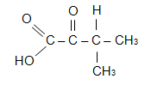

Which of the following substances could be oxidised to form the molecule above?

(a) CH3CHOHCH(CH3)CH3

(b) CH3CH(CH3)CHOHCH2OH

(c) CH2OHCH2COH(CH3)CH3

(d) CH3CHOHCH(CH3)CH2OH

11. Polystyrene is a polymer used in the packaging industry.

The formula of polystyrene is {-CH2CH (C6H5 )-}*n*

The monomer for this polymer has the molecular formula

(a)C8H6

(b)C8H7

(c)C8H8

(d)C8H9

12. What is the systematic name for the following?

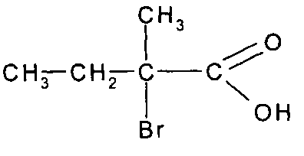

(a) 2-bromo-2-methylbutanoic acid

(b) 3-bromo-3-methylbutanoic acid

(c) *trans*-2-pentanoic acid

(d) *cis*-3-pentanoic acid

13. How many of the following compounds can exhibit geometric (cis-trans) isomerism?

* 1,1 – dibromopropene
* 1,2 – dibromopropene
* 2,3 – dibromopropene
* 3,3 – dibromopropene

(a) 1

(b) 2

(c) 3

(d) 4

14. Which of the following statements are true about the compound represented by the formula below?

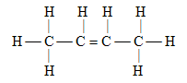

I it is soluble in water.

II it decolourises bromine water.

III it undergoes addition reactions with hydrogen chloride to form two different isomers with the formula C4H9Cl.

IV its systematic name is trans-2-butene.

(a) I only.

(b) II only.

(c) II and III only

(d) I, II, III and IV.

15. For the reaction

N2(g) + 3H2(g)  2NH3(g) H = - 92 kJ

Which of the following statements is **FALSE**?

(a) reducing the volume of the container will increase the rate of reaction.

(b) removal of NH3(g) may prevent equilibrium being achieved.

(c) reducing the temperature will increase the rate of reaction because it’s

exothermic.

(d) increasing the partial pressure of nitrogen gas will increase the rate of

reaction.

16. At room temp NO2 (brown) exists in equilibrium with N2O4 (colourless).

2NO2(g)  N2O4(g) ΔH = - 58.2 kJ mol-1

When one capsule containing an equilibrium mixture at room temperature is plunged into cold water, the intensity of the brown colour of the mixture

(a) increases, and K increases.

(b) decreases, and K stays the same.

(c) decreases and K increases.

(d) increases, and K decreases.

17. Carbon monoxide and chlorine react to form phosgene (COCl2). The reaction is reversible.

CO (g) + Cl2 (g) ⇌ COCl2 (g) + 35 kJ

Which of the following conditions will increase the rate of formation of phosgene?

1. Increasing the temperature
2. Increasing the pressure
3. Removal of phosgene
4. Decreasing the temperature
5. Decreasing the pressure

(a) I and II

(b) I, II and III

(c) III, IV and V

(d) IV and V

18. In which of the following is the first species acting as a base?

(a) HCO3− + NH3 ⇌ CO32− + NH4+

(b) H2PO4− + HCO3− ⇌ HPO42− + H2CO3

(c) HPO42− + NH4+ ⇌ H2PO4− + NH3

(d) SO42− + Ba2+ ⇌ BaSO4

19. Which of the following ions is least likely to act as a base in aqueous solution?

(a) CO32−

(b) HPO42−

(c) CH3COO−

(d) HSO4−

20. Which of the following ions does not have a conjugate base?

(a) CH3COO−

(b) HCO3−

(c) NH4+

(d) H3O+

21. Which of the following solution combinations would produce a green precipitate when mixed together?

1. NaCl, Ni(NO3)3, KCH3COO, AgNO3
2. Cr(NO3)3, KCl, Na2CO3, NH4NO3
3. NH4Cl, NaCH3COO, Ni(NO3)2, FeCl2
4. CuSO4, NaNO3, KCH3COO, CrCl3

22. The pH of water at 25 °C is 7, whereas the pH of boiling water is 6.14. This is due to the endothermic self-ionisation of water.

H2O (l) + H2O (l) ⮀ H3O+ (aq) + OH- (aq)

Which of the statements below is correct?

1. Boiling water has a higher concentration of hydronium ions present
2. Boiling water has a lower concentration of hydroxide ions present
3. Boiling water is more acidic
4. The pH of boiling water cannot be reliably measured

23. A very good rocket propellant can he made by allowing hydrogen and fluorine to react. They are light in mass and produce a greater amount of energy per unit mass than any other chemical fuel.

The potential energy diagram for the following reaction is shown below :

H2(g) + F2(g) ⮀ 2 HF(g)

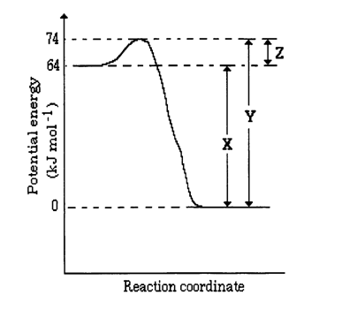

Raising the temperature of the system would initially :

(a) increase only the rate of the forward reaction.

(b) decrease only the rate of the reverse reaction.

(c) increase the rate of the forward reaction and decrease the rate of the reverse reaction.

(d) increase the rate of the reverse reaction more than it would increase the rate of the forward reaction.

24. Which of the following gases would occupy the largest volume?

(a) 0.10 mol of CO2 at 50°C and 1.0 kPa pressure

(b) 0.10 mol of H2 at 40°C and 1.0 kPa pressure

(c) 0.20 mol of CH4 at 50°C and 1.0 kPa pressure

(d) 0.10 mol of O2 at 50°C and 0.40 kPa pressure

25. When 40 mL of 1.0 mol L–1 BaCl2 solution is added to 10 mL of 2.0 mol L–1  K2SO4 solution, the amount in mole of BaSO4 precipitate formed is:

(a) 1.0 mol

(b) 0.020 mol

(c) 0.040 mol

(d) 0.060 mol

### END OF SECTION ONE

**Section Two: Short answer 35% (35 Marks)**

This section has **11** questions. Answer **ALL** questions. Write your answers in the answer book provided.

**Suggested working time: 60 minutes.**

1. Write balanced **ionic equations** and **full observations** for reactions that occur, **if any**, in the following experiments. You **MUST** use ionic equations. In your observations describe any colour change, precipitate (give colour) or gas evolution (colour and odour), resulting from the chemical reaction. In cases where you feel that no reaction is possible you must **state** this and describe the reactants that will not change!

(a) Small pieces of magnesium metal are added to a beaker containing

0.4M ethanoic acid solution.

(b) Acidified potasssium permanganate solution is added dropwise

to propanal.

(4 marks)

2. Draw the electron - dot diagrams for the following species:

(a) Sodium Bicarbonate (NaHCO3)

(b)CH2ClNH3+ ion

(2 marks)

3. Methane reacts with fluorine to form four different fluorinated compounds.

Write the formulas of all the fluorinated methanes that are **polar**. If the molecule is not polar do not write its formula as you will be penalised marks.

(2 marks)

4. This question refers to the following cell diagram:

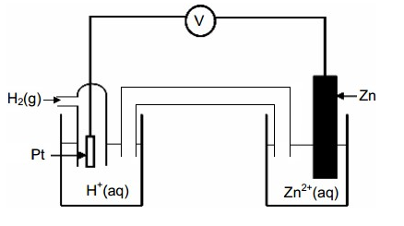

(a) What is the anode half-cell reaction?

(b) What is the cathode half-cell reaction?

(c) What is the cell E.M.F.?

(d) What is the significance of the left hand half-cell?

(e) What is the reducing agent in this cell reaction?

(f) Why was a platinum electrode chosen for the left hand half-cell?

(g) Had sodium carbonate been chosen as the salt-bridge electrolyte there would be the potential for side reactions to have occurred in the salt- bridge or the solutions in the beakers. List **two** possible products of these side reactions.

(4 marks)

5. **DRAW**  and **NAME** the principal **ORGANIC** molecule formed in the following reactions under appropriate conditions:

***\* You must show "H" for the position of all hydrogens!***

(a) Propanoic acid and methanol.

(b) Ethanol and limited dilute acidified potassium dichromate solution.

(c) Ethene and hydrogen chloride.

(d) Benzene and bromine.

(4 marks)

6. Silicone polymers are made by reacting chlorosilanes with water to form silanols as shown below:

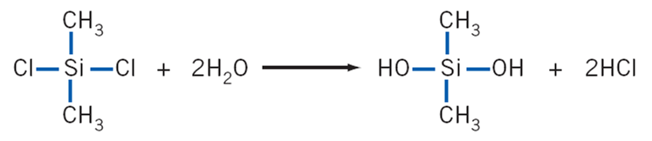

The silanols may then be dehydrated under certain conditions and will link to form silicone polymers.

(a) Why is the silicon containing product called a ‘silanol’?

(b) Draw **either** a **dimer** or the **smallest repeating unit** of a silicone polymer.

(c) The structure of the polyamide polymer ‘nylon 6,6’ is given below:

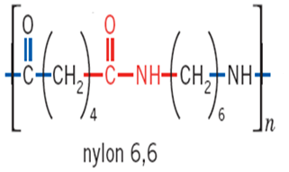

Explain in a sentence or two why ‘nylon 6,6’ would be a solid at room temperature whereas the silicone that you have drawn in part (b) is a liquid.

(4 marks)

7. The compound shown below gives cinnamon its characteristic flavour and odour. It is a pale yellow liquid that occurs naturally in the bark of cinnamon trees.

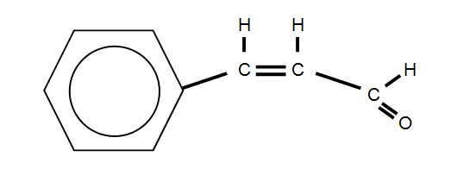

(a) **Name** the **two** main two functional groups present in the molecule.

(b) **Draw** the structure of the product that would be formed if the compound above was mixed with some liquid bromine.

(c) **Draw** the structure of the product that would be formed if the original compound above was mixed with an acidified solution of potassium permanganate.

(d) **Draw** the structure of the product that would be formed if the original compound above was polymerized in the presence of an appropriate catalyst such as ultraviolet light. You should show **either** a ***dimer*** or the ***smallest repeating unit*** of the polymer in your answer.

NB: ***You may wish to alter bond angles in the original molecule to make your task in part (d) easier.***

(4 marks)

8. A chromate/dichromate equilibrium can be represented as shown below:

Cr2O7-2(aq) + H2O(*l*) ↔ 2CrO4-2(aq)  + 2H+(aq)

Given that a sample solution is initially orange in colour, describe what you would observe upon the addition of sodium hydroxide solution. Explain this observation using appropriate equations **and** Le Chatelier’s Principle.

(2 marks)

9. Universal indicator was used to measure the pH of six solutions (each with a concentration of 0.5 mol L-1) and the results are shown in the diagram below.

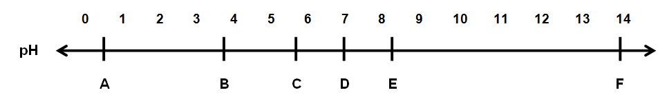

The six substances were;

KCl HF HCl NH4Cl KOH KF

(a) Which substance is most likely to be C? Explain your answer using an equation.

(b) Which substance is most likely to be F? Explain your answer using an equation.

(c) Name the two substances that would produce a buffer when mixed together.

(4 marks)

10. The concentrations of the three substances in the reaction:

PCl3(g) + Cl2(g) ⇔ PCl5(g) Δ*H* = - 93 kJ mol-1

are shown in the graph below:

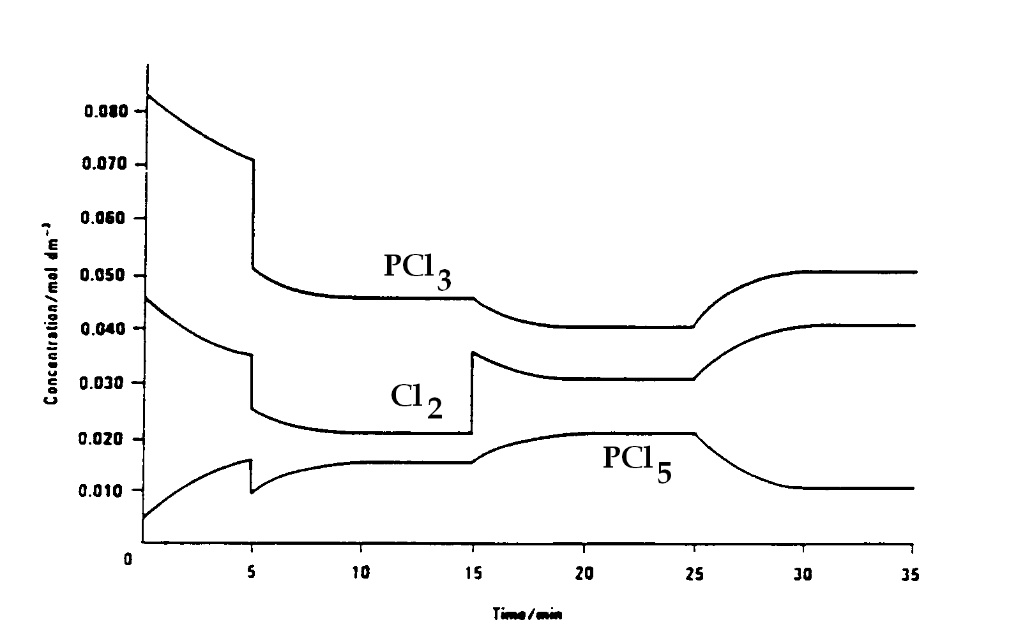

(a) Suggest what might have been done to the system at the 5 minute mark before it has come to equilibrium.

(b) Account for the horizontal section of the graph between the 20 and 25

minute marks.

(c) Suggest what may have been done to the system at the 15 minute mark?

(d) Suggest a change that could have been made to the system to bring about the changes after the 25 minute mark.

(e) How would the addition of a catalyst at the 5 minute mark have affected the shape of the curve between the 5 and 15 minute marks?

(f) Describe fully in terms of Le Chatelier’s principle the affect that injecting more PCl5(g) would have on the system at any time that it was in equilibrium, making sure to detail the new relative concentrations of each of the component gases when equilibrium is re-established.

(4 marks)

11. Acid base titrations may be categorized according the strength of the acid or base being titrated against each other. In your course you have studied three major categories:

(i) STRONG ACID v STRONG BASE (**SA v SB**)

(ii) STRONG ACID v WEAK BASE (**SA v WB**)

(iii) STRONG BASE v WEAK ACID (**SB v WA**)

Titration curves for two typical titrations are given below. Decide which category of titration is represented correctly by each curve. You need simply to state the category (you may use the abbreviations above) for each.

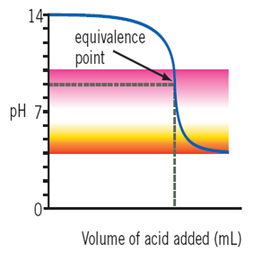

(a)

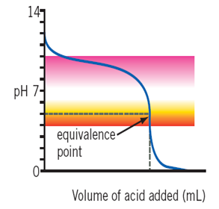 (b)

(1 mark)

**END OF SECTION TWO**

**Section Three: Extended answer 40% (40 Marks)**

This section contains **four (4)** questions. You must answer **ALL** questions. Write your answers in the answer book provided.

Any calculations are to be set out ***in detail*** on the paper provided. You may be penalized significantly for failure to show appropriate working, even if you obtain the correct numerical answer. Marks will be allocated for correct equations and clear setting out of a partial answer, even if you cannot complete the problem.

This part carries **40 marks**.

Numerical answers **MUST** be corrected to **THREE (3) SIGNIFICANT FIGURES**.

**Suggested working time: 70 minutes.**

1. Aspirin is a drug commonly used to reduce inflammation and to relieve pain.

The molecular structure of aspirin is given below:

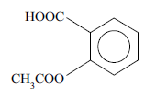

(a) What two major functional groups does this molecule contain?

(1 mark)

(b) What is the empirical formula of aspirin?

(1 mark)

(c) Aspirin is often taken in ionic form. The ionic form is achieved by reacting this monoprotic molecular form with bicarbonate ions. The reactants in an ionic equation are represented below:

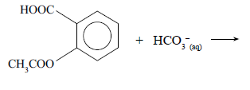

What are the **three** products of this reaction?

You may answer by either giving the chemical formula or drawing the molecular structure of the products depending on which is easier and most appropriate.

(2 marks)

(d) Explain in a paragraph why the ionic form is more soluble in water than the molecular form.

(3 marks)

(e) A patient is studied to determine the amount of Aspirin that is absorbed in his stomach. On one particular day of the study his stomach pH level is determined to be 2.1.

Calculate the concentration of hydrogen ions in his stomach.

(1 mark)

(f) In the stomach the ionic form of aspirin is in equilibrium with the molecular form as shown in the diagram below:

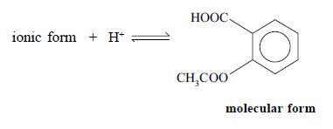

**State** and **explain**, in terms of the equilibrium above using Le Chatelier’s principle, which form of aspirin will be present in higher concentration in the stomach. You should answer in three or four sentences only.

(3 marks)

(g) On another day the study patient is suffering from indigestion or heartburn which can be caused by excess acid in the stomach. It is decided that the *excess* stomach acid should be treated with an antacid tablet. Bicarbonate of soda (NaHCO3) is the main constituent of indigestion tablets which are used to neutralise excess stomach acid (HCl) according to the equation:

NaHCO3 (aq) + HCl (aq) NaCl (aq) + H2O (l) + CO2 (g)

A particular indigestion tablet weighs 3.0 g and 70% of this tablet

(by mass) is NaHCO3 . If two tablets exactly are required to neutralise the excess stomach acid,

(i) calculate this mass of excess HCl produced by the patient.

(ii) calculate the pH of the aqueous stomach contents prior to treatment with antacid given that the volume of excess acid solution neutralised in part (i) was 35mL.

(4 marks)

2. An organic compound is known to contain the elements carbon, hydrogen, nitrogen and oxygen. Combustion of a 6.922g sample of this compound yields 11.83g of carbon dioxide and 5.442g of water, the mixture of nitrogen oxides was not analysed. A further 6.922g sample of the compound was found to contain a percentage mass of Nitrogen of 13.59%

(a) Calculate the mass of nitrogen in the 6.922g sample.

(0.5 mark)

(b) Calculate the empirical formula of the compound.

(5 marks)

(c) Given that the molecular weight is 103.112 g.mol-1 determine the molecular formula.

(0.5 marks)

(d) Given that the molecule is an alpha-amino acid give a possible molecular structure **and** the I.U.P.A.C. name for the amino acid molecule.

(2 marks)

(e) The material produced was found to polymerise with the amino acid glycine, which has the formula;

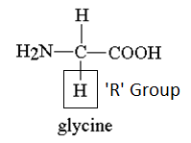

Rearrange the amino acid from part (d) so that its formula has the same relative appearance as that of glycine above with the 'R' group pointing down the page and then show a dimer (linked group of two monomers only) of the amino acid from part (d) and glycine. Once you have done this **circle the peptide linkage**.

(1.5 marks)

(f) Draw the zwitterion of glycine formed in near neutral pH solutions.

(1 mark)

3. Benzene (C6H6) can be produced by the dehydrogenation of cyclohexane (C6H12) gas. The reaction has a high activation energy (880 kJ mol−1), is also endothermic and reversible. The cyclohexane (C6H12) passes through a special reaction tower where hydrogen is chemically removed. The benzene/cyclohexane/hydrogen mixture then passes through a compressor, where the benzene is liquefied. A special membrane in the compressor allows the small hydrogen molecules to pass through, and out. The unreacted cyclohexane (C6H12) gas is then returned to the reaction tower.

**C6H12 (g) + 120 kJ ⇌ C6H6 (g) + 3 H2 (g)**

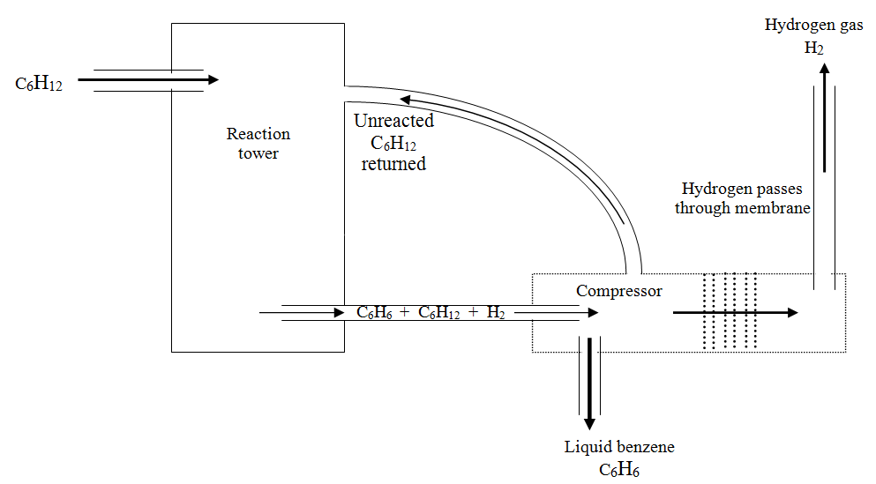

(a) Draw a labeled energy profile diagram for the reaction that is **roughly to scale** and indicates clearly the ***actual reactant*** and ***product*** particles and their relative energy. You must also show the ***activated complex***, ***activation energy*** for the ***forward and reverse*** reaction as well as the ***∆H of reaction***, make sure to indicate the ***sign and value of your ∆H*** when you show it on the graph.

(3 marks)

(b) Write an equilibrium constant expression for the reaction.

(0.5 marks)

(c) Under what environmental conditions will the **rate** of the forward reaction be greatest?

(1 mark)

(d) How does the liquefaction of the benzene assist the yield achieved in the reaction tower?

(1 mark)

(e) Suggest conditions of temperature and pressure that would be used for the commercial production of benzene using this process.

Explain why you chose these conditions making reference to Le Chatelier's principle.

(4 marks)

4. Scott was entrusted to housesit for his parents whilst they were on an overseas holiday. The day before they were due to come home he noticed a large green stain on the brand new carpet. Being a chemist he realised that he needed a cleaner that was at least 4.00% ammonia (NH3) by mass, as this was a particularly stubborn stain to remove. With time being of the essence he decided to analyse his new commercial brand of cleaner known as “cloudy ammonia” to see if it would be up to the task.

14.928g of “cloudy ammonia” cleaner was placed in a 250mL volumetric flask and made up to the mark. 25.0mL aliquots of this solution required, on average, 22.8mL of 0.128 mol.L-1 H2SO4 for neutralisation. Calculate the percentage of ammonia by mass in Scott’s new floor cleaner.

(4 marks)

### END OF SECTION THREE

**END OF PAPER**